Contents
FLOWCHARTS 1
Log in 1
Register 2
Making a booking 3

FLOWCHARTS

Log in
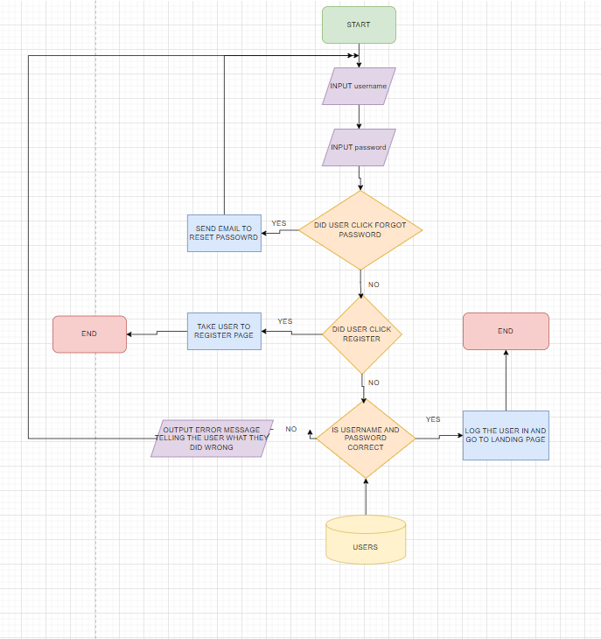
The user will be prompted to enter their username and password the system will then check if the user clicked other options like forgot password or register if they did it will take the appropriate actions like sending a reset email link or taking the user to the register page if not the system will check if the username and password match the ones in the database and if not, not, it will send an error message telling the user what they did wrong if its correct the system will log the user in return them to the landing page.

Register
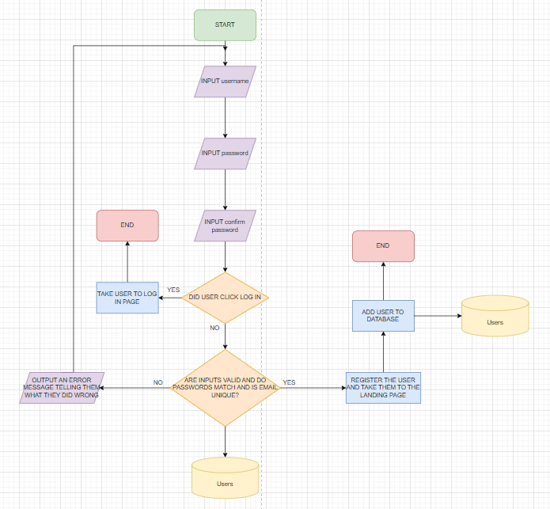
The user will be prompted to enter their username and password and password again to confirm it, the system then checks if the two passwords match and if the email is unique to any other account from the database, then they can proceed to add the user to the database if everything is good but if there are any issues the system prompts the user with an error message explaining what they have done wrong and asks them to try gaain.

Making a booking
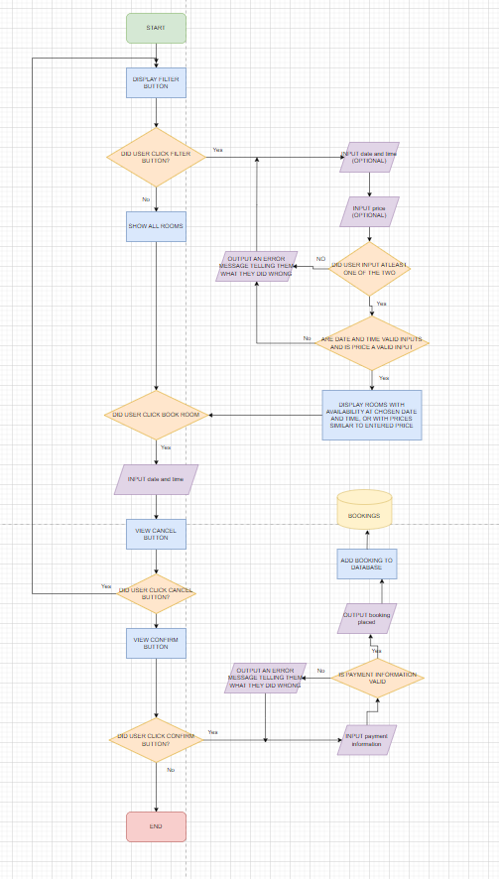
The page loads up showing all rooms available to book and also a filter button, tif the user chooses to filter the rooms they are asked to filter by price or by availability at a certain date and time, the user must choose one of the two and the system displays the necessary rooms in which they have filtered to. When the user finds the room that they want they can click the book room button, enter the details of their booking and click confirm, there they will be asked to pay and if their payment is successful, they will receive a booking confirmation message and the booking will be added to the database. The system is quipped with fail safes meaning if the user enters the wrong things at any time the user is given an error message explaining what went wrong and are prompted to try again.

Staff confirming or denying bookings
